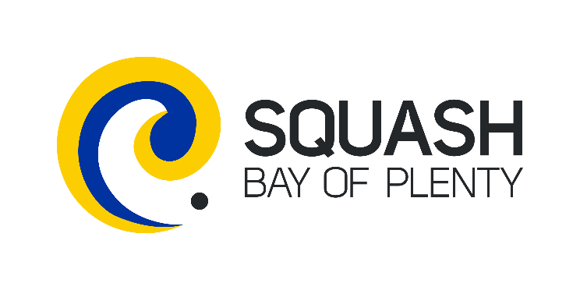

SQUASH CLUB OF THE YEAR 2018-2019
NOMINATION FORM

INTRODUCTION
Clubs play an important role in society. They draw people together, they help knit communities and they provide a place where people can enjoy themselves both on and off the court.

REGIONAL CLUB OF THE YEAR AWARD
The Club of they Year Award is made annually by the regional District Associations and recognises achievement from affiliated squash clubs. Members are asked to nominate their clubs and to provide a description of their achievements in the delivery of community squash. A judging panel chosen by the District representatives decides the winner. The judging panel’s decision is final, and no correspondence or discussion will be entered into.

NATIONAL CLUB OF THE YEAR AWARD
Winners from each of the 11 regional District Associations are put forward as contenders for the coveted National Award. A judging panel decides the winning club and a representative will be presented with the trophy at an awards evening on Saturday 30th November at the Novotel Airport Hotel in Auckland. The judging panel’s decision is final, and no correspondence or discussion will be entered into.

JUDGING CRITERIA
Clubs will be judge on good practice and success in all areas of club development under the following five areas:

- Participation Growth (eg. Engagement with the community (e.g. other clubs, schools), Coach development process in place, Programmes offered for different participant groups, Retention and growth of overall membership, Website and social media used to create engagement online presence.
- Player/Club Performance (eg. Regional/National results and improvements of players/teams, Evidence of hosting successful events, Attendance rates at other events
- Welcoming facilities (eg. Facility upgrades and maintenance completed, Volunteer management strategies in place, New Member management processes, Club promotion and signage
- Financial Health (eg. Club/business plan used, Financial sustainability/viability achieved, Sound leadership (role descriptions, robust governance practices, Commercial sponsorship relationships.
- Unified Delivery (eg. Alignment and collaboration with regional/national bodies, User of iSquash for operations/reporting.

NOMINATION TERMS AND CONDITIONS
Achievements by Clubs will only be considered if they have occurred during the period 1 October 2018 to 30 September 2019.

Clubs under consideration for the Regional and National Awards must:
- Be affiliation to Squash NZ and one of the 11 regional Squash District Associations
- Be happy for Squash NZ to contact them using the information provided as part of the nomination
- Have a spokesperson from the Club be available for interviews, photos and other media or promotional events in relation to the award.

CLUB CONTACT DETAILS
Name of Club |  | District
Postal Address
Club website
Contact Person |  | Role
Contact Phone |  | Mobile
Email Address

NOMINEE DETAILS
Name
Contact Phone |  | Mobile
District:
Email Address

CLUB’S ACHIEVEMENTS

Information presented in the nomination form must be clear, concise and accurate as it is used by the judging panel to make an informed and final decision on finalists and winners. Please ensure you provide information on the Club and their achievements as if the judging panel knows nothing.

1. HOW DID THE CLUB CONTRIBUTE TO AND/OR ACHIEVE PARTICIPATION GROWTH?
Increasing the number of people playing and participating in squash this year

2. HOW DID THE CLUB CONTRIBUTE TO PLAYER/CLUB PERFORMANCE?
Club members achieving success at regional/national events this year

3. HOW DID THE CLUB CONTRIBUTE TO AND/OR ACHIEVE WELCOMING FACILITIES?
Improving the condition, accessibility and utilization of the Club’s space this year

4. HOW DID THE CLUB CONTRIBUTE TO AND/OR ACHIEVE FINANCIAL HEALTH?
Governing and managing the Club to provide financial sustainability this year

5. HOW DID THE CLUB CONTRIBUTE TO AND/OR ACHIEVE UNIFIED DELIVERY?
Working with the District and Squash NZ to deliver squash in the community this year

OTHER INFORMATION
Please provide any other information that you feel is relevant

CONFIRMATION

On behalf of the aforementioned club, I declare that all the information provided with this application is true and correct.

Signature
Name
Role

Please email the completed form to admin@squashbop.co.nz
This form must be received by Squash BOP by 18 October.

